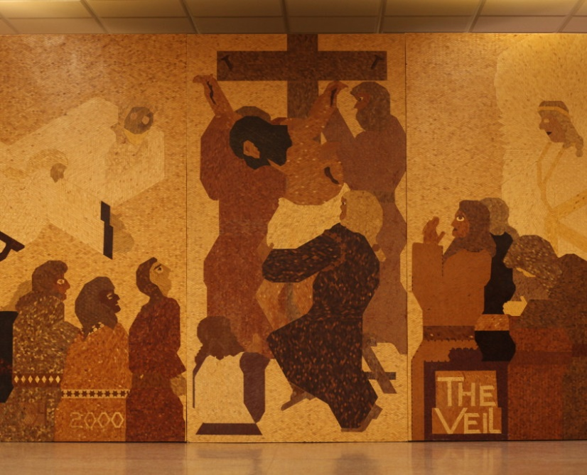

Lenten Projects
- Catching up “Finding my Way through the Bible”- a two session course with workbook that then entitles your child to his /her “first personal bible” that is blessed and offered at Liturgy. This is for you if your child is in fifth grade or higher and missed this opportunity in the past.
- Catching up with “Making Things Right”—a three session course with workbook that prepares your child for his/her “first Confession” on Saturday April 9 at 3:00 PM. This is for your child if your child is in third grade or higher and missed this opportunity in the past.
- The above don’t apply to my child and I want a “Lenten Reading Contract” for my child to follow during the 40 days of Lent.
Lenten Retreat
“My Father’s Love” exhibit in Libertyville, Illinois. Saturday,April 9 at 1:00. We would leave the Cathedral at 1:00 PM after potluck lunch. Memorial Saturday Liturgy at 9:30 encouraged along with Confession at 3:00 PM.
Options:
- We can carpool from the Cathedral and back.
- We can rent a bus from the Cathedral and back. (Need at least 20)
- We can each get there on our own. Only option if you can’t make the rest of the day activities.

This takes a lot of planning and materials. Please respond by either emailing back of bringing m a form for each family by March 13.

