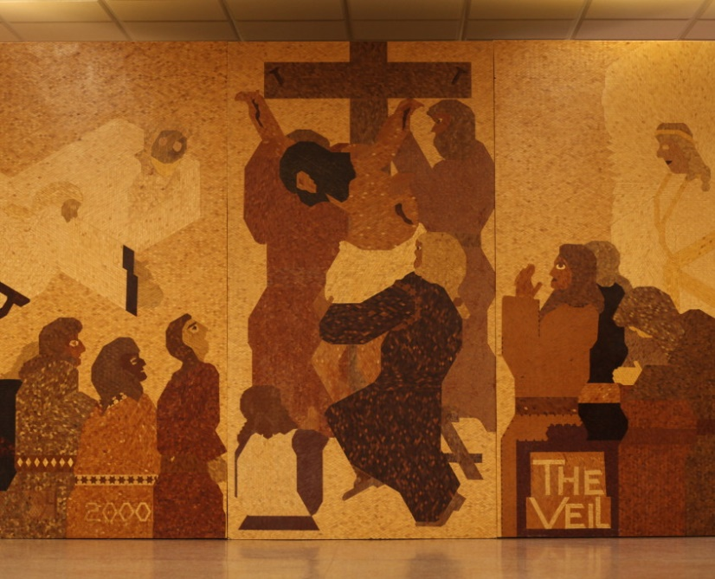
Please return by Sunday, March 14
Lenten Project
Family Name______________________________________________________________

Lenten Projects (at least one parent must also come to the sessions)
Finding my Way through the Bible
Child’s Name____________________________
Two Session Dates________________________

Making Things Right
Child’s Name____________________________
Three Session Dates_______________________

Lenten Reading Contract
Child’s Name____________________________

Lenten Retreat Saturday, April 9 (at least one parent must also come)
We cannot make the retreat________________
We can come to Liturgy and /or Confession/Pot Luck_______________
We want to carpool to Mundelein______________________
If available we want to rent a bus (cost depends on how many)____________
We cannot make the retreat but will meet you at Mundelein at 1 PM______________

You are welcome to invite friends, relatives to the outing.

Sessions times for Lenten Projects
March 12, March 19, April 2---Saturdays from 3:30pm to 4:15pm
March 11, March 18 ---Fridays from 5:30pm to 6:15pm
March 20, April 3 ---Sundays from 1:00pm to 1:45pm

